Volunteers’ Management System
Quality Assurance Plan

Version 1.4

Revision History
Date | Version | Description | Author
23 October 2009 | draft | Fill parts 1, 2,3,4,5 | Abdollah Tabareh
25 October 2009 | 0.1 | Fill part 6 | Tigran Harutyunyan
25 October 2009 | 0.2 | Fill part 6 | Mustafa Al Zubaidi
27 October 2009 | 1.0 | Review and edit | Abdollah Tabareh
08 November 2009 | 1.1 | Edit 7,6,2 | Abdollah Tabareh
17 November 2009 | 1.3 | Change and edit according to review | Abdollah Tabareh
17 November 2009 | 1.4 | Change and edit according to review | Mustafa Al-Zubaidi

Table of Contents
1.Introduction
2. Management
2.1.Organization
2.2.Tasks and Responsibilities
3. Documentation
4. Standards and Guidelines
5. Metrics
6. Review and Audit Plan
7. Tools
Quality Assurance Plan

1. Introduction
This document explains plans for assuring the quality throughout this project.

2. Management

2.1 Organization
In this project, all members are part of quality system, but we have also hierarchies for quality check which is shown in the bellowing diagram.
Direction of arrows shows the subject and object of actions.
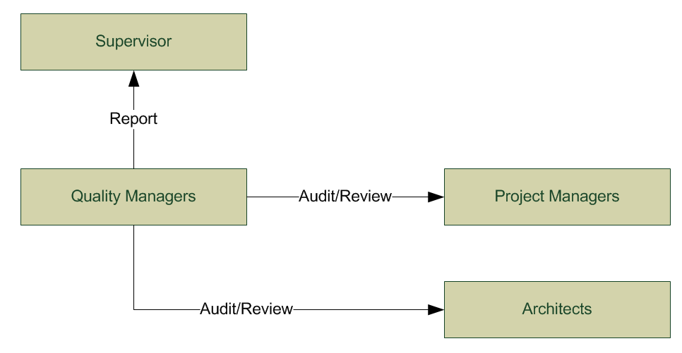
Organization of quality assurance

2.2 Tasks and Responsibilities
Quality managers are responsible of quality of artifacts and project and will be eyes of supervisor inside the project. They have to measure quality of deliverables at the end of each iteration and generate a Quality Report for supervisor of the project. They also have to check each deliverable after submitting as a complete artifact and open a bug in bug tracking system for each deliverable and write all the bugs they found inside the bug.
Each member in the project team is responsible for the quality of his/her artifact before hand over it to Project Managers as a result of a completed task. This individual task will be performed based on agreed checklists and guidelines for each artifact at the task assignment point and a spelling and grammar check after completing the deliverable.
Supervisor may check and measure the quality of artifacts and report some faults which have to be affected on them and result in a major release of artifacts.

3. Documentation
Documents which will be produced for the quality assurance and imply the quality in this project are:
- Checklists for artifacts which will be defined before assigning tasks to team members.
- Reports of quality which contain a statistical table. In the table there are columns which show the total number of defects for each artifact and the number of defects in each severity category.

4. Standards and Guidelines
Project team follows these technical documents:
- RUP Guidelines for activities and artifacts
- UML 2.0 Standards

5. Metrics
There are some metrics which will be used during the quality assurance activities. You can also find the definition and purpose of these metrics and the way they will be collected.

Name | Number of defects for artifacts
Definition | Number of defects found in an artifact during a quality check.
Goals | Shows an aspect of quality in artifacts
Analysis Procedure | By counting the number of defects inside an artifact after quality review.
Responsibilities | Quality Managers

Name | Defects severity
Definition | A table which shows the open defects of the documentations and their severity. This project will have 3 severity levels.  - Level 1: Defects which intensively harm the usability of artifacts.  - Level 2: Defects which with them, still artifacts are usable.  - Level 3:Defects which relates to complementary items
Goals | Shows an aspect of quality in artifacts.
Analysis Procedure | Distribute defects of software inside severity categories considering the criteria. At last a table consists of severity levels with number and percent of defects in each of them will form the result.
Responsibilities | Quality Managers

6. Review and Audit Plan

6.1 Quality of artifacts
The procedure of quality check for each artifact is the same. When the task assigned to members, team will agree on a template and guideline for the resulting artifacts. After finishing development of an artifact, it will be sent to the team for checking for faults based on the agreed templates and guidelines. All faults will be written in the opened bug in bug tracking system. Responsible of task which the artifacts resulted from, has to fix all bugs reported. Throughout the fixing procedure for a bug, Project Managers may want to assign other members for fixing a part of a bug. After fixing the bug, Quality Managers have to review and check if all the bugs fixed or not and after approval the bug can be closed. At the end of each iteration, Quality Managers have to assess the quality of artifacts and report the amount of defects in each of them and severity of defects as well. If we find any suggestions/defects for an artifact by supervisor side, a bug will reopen for that artifact and the same bug fixing procedure will be followed.
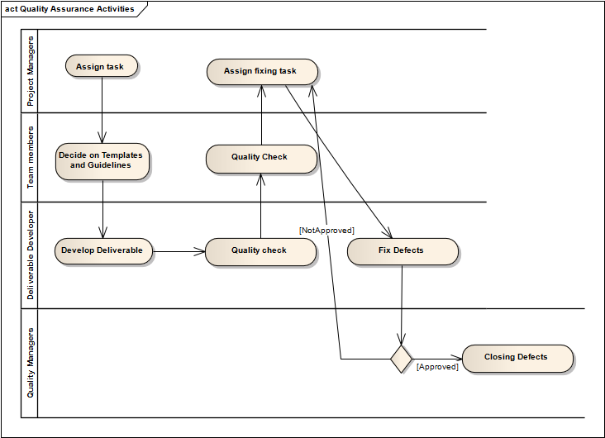
Quality Assurance Activities

7 Tools
Since the project is using Google Code for document control system, Google issue tracking system is a suitable solution for tracking the defects of the deliverables. Google issue tracking system provides features for opening a bug, editing, and closing the bug and they’re enough for automate the quality assurance process in the project team. Roles and responsibilities and workflows are described in “Tasks and Responsibilities” section of this document.

RUP process documents
http://code.google.com/p/support/wiki/IssueTracker

